DIGITAL LEARNING
(INTERNET, SOCIAL MEDIA AND DIGITAL DEVICES)
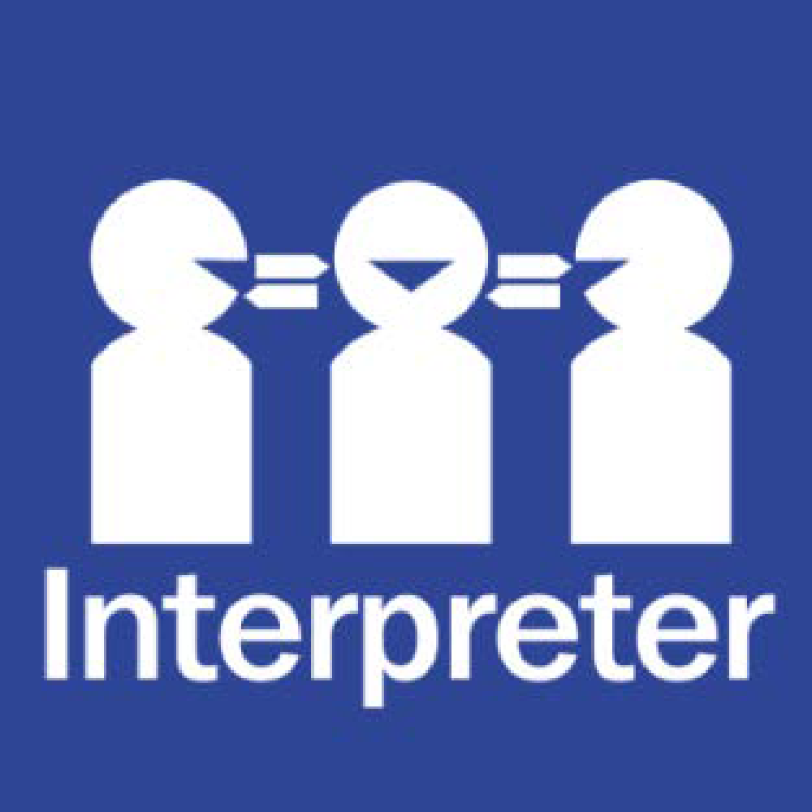
Help for non-English speakers
If you need help to understand the information in this policy please contact Bulleen Heights School on 9850 7122

PURPOSE
To ensure that all students and members of our school community understand:
- our commitment to providing students with the opportunity to benefit from digital technologies to support and enhance learning and development at school including our 1-to-1 personal device program.
- expected student behaviour when using digital technologies including the internet, social media, and digital devices (including computers, laptops, tablets)
- the school’s commitment to promoting safe, responsible and discerning use of digital technologies, and educating students on appropriate responses to any dangers or threats to wellbeing that they may encounter when using the internet and digital technologies
- our school’s policies and procedures for responding to inappropriate student behaviour on digital technologies and the internet
- the various Department policies on digital learning, including social media, that our school follows and implements
SCOPE
This policy applies to all students and staff at Bulleen Heights School.
Staff use of technology is also governed by the following Department policies:
- Acceptable Use Policy for ICT Resources
- Cybersafety and Responsible Use of Digital Technologies
- Digital Learning in Schools and
- Social Media Use to Support Student Learning.
Staff, volunteers and school councillors also need to adhere to codes of conduct relevant to their respective roles. These codes include:
- Bulleen Heights School’s Child Safety Code of Conduct
- The Victorian Teaching Profession Code of Conduct (teaching staff)
- Code of Conduct for Victorian Sector Employees (staff)
- Code of Conduct for Directors of Victorian Public Entities (school councillors)
DEFINITIONS
For the purpose of this policy, “digital technologies” are defined as digital devices, tools, applications and systems that students and teachers use for learning and teaching; this includes Department-provided software and locally sourced devices, tools and systems.
POLICY

Vision for digital learning at our school
The use of digital technologies is a mandated component of the Victorian Curriculum F-10.
Safe and appropriate use of digital technologies, including the internet, apps, computers and tablets, can provide students with rich opportunities to support learning and development in a range of ways.
Through increased access to digital technologies, students can benefit from learning that is interactive, collaborative, personalised, engaging and transformative. Digital technologies enable our students to interact with and create high quality content, resources and tools. It also enables personalised learning tailored to students’ particular needs and interests and transforms assessment, reporting and feedback, driving new forms of collaboration and communication.
Bulleen Heights School believes that the use of digital technologies at school allows the development of valuable skills and knowledge and prepares students to thrive in our globalised and inter-connected world. Our school’s vision is to empower students to use digital technologies safely and appropriately to reach their personal best and fully equip them to contribute positively to society as happy, healthy young adults.

Personal Devices at Example School
Bulleen Heights School operates a Bring Your Own Device (BYOD) program. Classes at our school are delivered with the use of iPads.
Parents/carers are invited to purchase or lease a device for their child to bring to school. Bulleen Heights School has made special arrangements with providers who offer discounted prices for the lease or purchase of devices for our students. Example School can refer parents to government or community support programs that may help them if they wish to purchase a device for their child to own, rather than use what is provided for free by the school.
Students are invited to bring their own device to school each day to be used during class time for different learning activities. When bringing their own device to school, students should ensure that it:

- Is fully charged each morning
- Is brought to school in a protective case

Please note that our school does not have insurance to cover accidental damage to students’ devices, and parents/carers are encouraged to consider obtaining their own insurance for their child’s device.
Students, parents and carers who would like more information or assistance regarding our BYOD program are encouraged to contact Mel Greaves or Eva Chakrabarty on 9850 7122
The school aims to encourage and assist students to develop the knowledge, understanding and skills to ensure that students:

design, create, manage and evaluate sustainable and innovative digital solutions to meet and redefine current and future needs
use computational thinking and the key concepts of abstraction; data collection, representation and interpretation; specification, algorithms and development to create digital solutions
apply systems thinking to monitor, analyse, predict and shape the interactions within and between information systems and the impact of these systems on individuals, societies, economies and environments
confidently use digital systems to efficiently and effectively automate the transformation of data into information and to creatively communicate ideas in a range of settings
apply protocols and legal practices that support safe, ethical and respectful communications and collaboration with known and unknown audiences

Safe and appropriate use of digital technologies
Digital technologies, if not used appropriately, may present risks to users’ safety or wellbeing. At Bulleen Heights School, we are committed to educating all students to use digital technologies in ways that respect the dignity of ourselves and others and promote full flourishing for all, equipping students with the skills and knowledge to navigate the digital world.

At Bulleen Heights School, we:
- use online sites and digital tools that support students’ learning, and focus our use of digital technologies on being learning-centred
- use digital technologies in the classroom for specific purpose with targeted educational or developmental aims
- supervise and support students using digital technologies for their schoolwork
- effectively and responsively address any issues or incidents that have the potential to impact on the wellbeing of our students
- have programs in place to educate our students to be safe, responsible and discerning users of digital technologies.
- educate our students about digital issues such as privacy, intellectual property and copyright, and the importance of maintaining their own privacy and security online
- actively educate and remind students of our PBS and Student Engagement policy that outlines our School’s values and expected student behaviour, including online behaviours
- have an Acceptable Use Agreement outlining the expectations of students when using digital technologies for their schoolwork
- use clear protocols and procedures to protect students working in online spaces, which includes reviewing the safety and appropriateness of online tools and communities and removing offensive content at the earliest opportunity
- educate our students on appropriate responses to any dangers or threats to wellbeing that they may encounter when using the internet and other digital technologies
- provide a filtered internet service at school to block access to inappropriate content
- refer suspected illegal online acts to the relevant law enforcement authority for investigation
- support parents and carers to understand the safe and responsible use of digital technologies and the strategies that can be implemented at home through regular updates in our newsletter, information sheets, website/school portal and information sessions.
Distribution of school owned devices to students and personal student use of digital technologies at school will only be permitted where students and their parents/carers have completed a signed Acceptable Use Agreement.
It is the responsibility of all students to protect their own password and not divulge it to another person. If a student or staff member knows or suspects an account has been used by another person, the account holder must notify ICT leader immediately.
All messages created, sent or retrieved on the school’s network are the property of the school. The school reserves the right to access and monitor all messages and files on the computer system, as necessary and appropriate. Communications including text and images may be required to be disclosed to law enforcement and other third parties without the consent of the sender.

Social media use
Our school follows the Department’s policy on Social Media Use to Support Learning to ensure social media is used safely and appropriately in student learning and to ensure appropriate parent notification occurs or, where required, consent is sought. Where the student activity is visible to the public, it requires consent.
Our school has established the use of See Saw for students to showcase their work, where parents can provide appropriate feedback and comments on the work undertaken in or relating to our classes. Parents are welcome to contact the ICT coach if they have any questions or concerns about students participating in this platform.
In accordance with the Department’s policy on social media, staff will not ‘friend’ or ‘follow’ a student on a personal social media account, or accept a ‘friend’ request from a student using a personal social media account unless it is objectively appropriate, for example where the student is also a family member of the staff.
If a staff member of our school becomes aware that a student at the school is ‘following’ them on a personal social media account, Department policy requires the staff member to ask the student to ‘unfollow’ them, and to notify the school and/or parent or carer if the student does not do so.

Student behavioural expectations
When using digital technologies, students are expected to behave in a way that is consistent with Bulleen Heights School’s Statement of Values, Student Wellbeing and Engagement policy, and Bullying Prevention policy.
When a student acts in breach of the behaviour standards of our school community (including cyberbullying, using digital technologies to harass, threaten or intimidate, or viewing/posting/sharing of inappropriate or unlawful content), Bulleen Heights School will institute a staged response, consistent with our student engagement and behaviour policies.
Breaches of this policy by students can result in a number of consequences which will depend on the severity of the breach and the context of the situation. This includes:
- removal of network access privileges
- removal of email privileges
- removal of internet access privileges
- removal of printing privileges

COMMUNICATION

This policy will be communicated to our school community in the following ways:
- Included in staff induction processes
- Discussed at staff briefings/meetings as required
- Discussed at parent information nights/sessions
- Included in transition and enrolment packs
- Discussed at student forums/through communication tools
- Made available in hard copy from school administration upon request
POLICY REVIEW AND APPROVAL
Policy last reviewed | August 2021
Approved by | Principal: Susan Merjan and School Council
Next scheduled review date | August 2023

