BULLYING PREVENTION POLICY
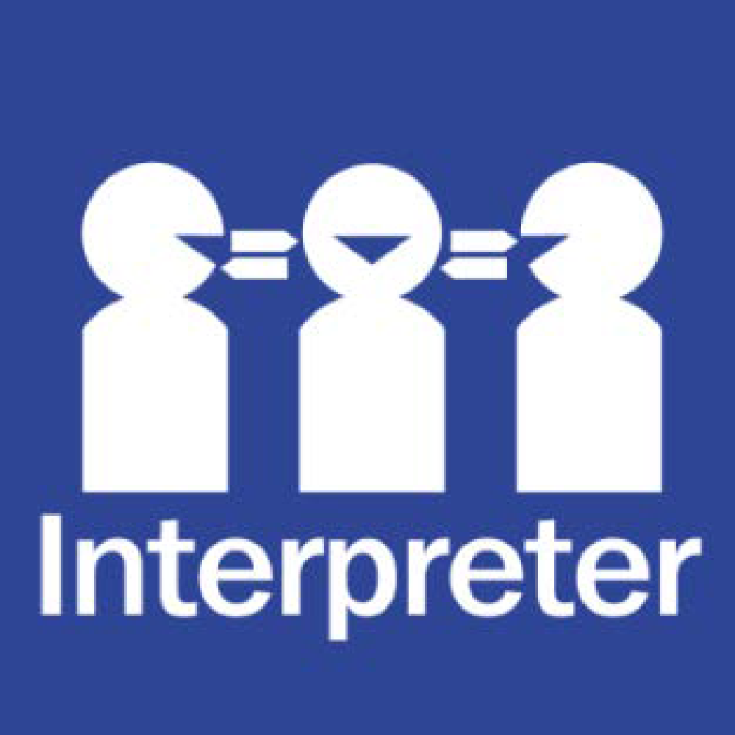
Help for non-English speakers
If you need help to understand the information in this policy please contact Bulleen Heights School on 9850 7122

PURPOSE
Bulleen Heights School is committed to providing a safe and respectful learning environment where bullying will not be tolerated.
The purpose of this policy is to:
- explain the definition of bullying
- follow the SWPBS bully prevention curriculum
- make clear that all forms of bullying at Bulleen Heights School will not be tolerated
- ask that everyone in our school community be alert to signs and evidence of bullying behaviour, and accept responsibility to report bullying behaviour to school staff
- ensure that all reported incidents of bullying are appropriately investigated and addressed
- ensure that support is provided to students who may be affected by bullying behaviour (including victims, bystanders and perpetrators)
- seek parental and peer group support in addressing and preventing bullying behaviour at Bulleen Heights School.
When responding to bullying behaviour, Bulleen Heights School aims to:
- be proportionate, consistent and responsive
- find a constructive and positive solution for everyone
- stop the bullying from happening again
- restore the relationships between the students involved.
Bulleen Heights School acknowledges that school staff owe a duty of care to students to take reasonable steps to reduce the risk of reasonably foreseeable harm, which can include harm that may be caused by bullying behaviour.
Corporal punishment is not permitted at Bulleen Heights School.

SCOPE
This policy addresses how Bulleen Heights School aims to prevent, address and respond to student bullying behaviour. Bulleen Heights School recognises that there are many other types of inappropriate student behaviours that do not meet the definition of bullying which are also unacceptable at our school. These other inappropriate behaviours will be managed in accordance with our codes of conduct policies.
This policy applies to all school activities, including camps and excursions.

POLICY

Definitions
Bullying
In 2018 the Education Council of the Council of Australian Governments endorsed the following definition of bullying for use by all Australian schools:
Bullying is an ongoing and deliberate misuse of power in relationships through repeated verbal, physical and/or social behaviour that intends to cause physical, social and/or psychological harm. It can involve an individual or a group misusing their power, or perceived power, over one or more persons who feel unable to stop it from happening.
Bullying can happen in person or online, via various digital platforms and devices and it can be obvious (overt) or hidden (covert). Bullying behaviour is repeated, or has the potential to be repeated, over time (for example, through sharing of digital records)
Bullying of any form or for any reason can have immediate, medium and long-term effects on those involved, including bystanders. Single incidents and conflict or fights between equals, whether in person or online, are not defined as bullying.
Bullying has three main features:
- It involves a misuse of power in a relationship
- It is ongoing and repeated, and
- It involves behaviours that can cause harm.
Bullying can be:
- direct physical bullying – e.g. hitting, tripping, and pushing or damaging property.
- direct verbal bullying – e.g. name calling, insults, homophobic or racist remarks, verbal abuse.
- indirect bullying – e.g. spreading rumours, playing nasty jokes to embarrass and humiliate, mimicking, encouraging others to socially exclude a person and/or damaging a person’s social reputation or social acceptance.
Cyberbullying is direct or indirect bullying behaviours using digital technology. For example via a mobile device, computers, chat rooms, email, social media, etc. It can be verbal, written and include images, video and/or audio.
Other distressing and inappropriate behaviours
Many distressing and inappropriate behaviours may not constitute bullying even though they are unpleasant. Students who are involved in or who witness any distressing and inappropriate behaviours should report their concerns to school staff and our school will follow the Student Wellbeing and Engagement Policy/Student Engagement Policy/Code of Conduct.
Mutual conflict involves an argument or disagreement between people with no imbalance of power. In incidents of mutual conflict, generally, both parties are upset and usually both want a resolution to the issue. Unresolved mutual conflict can develop into bullying if one of the parties targets the other repeatedly in retaliation.
Social rejection or dislike is not bullying unless it involves deliberate and repeated attempts to cause distress, exclude or create dislike by others.
Single-episode acts of nastiness or physical aggression are not the same as bullying. However, single episodes of nastiness or physical aggression are not acceptable behaviours at our school and may have serious consequences for students engaging in this behaviour. Bulleen Heights School will use its Student Wellbeing and Engagement Policy to guide a response to single episodes of nastiness or physical aggression.
Harassment is language or actions that are demeaning, offensive or intimidating to a person. It can take many forms, including sexual harassment and disability harassment. Further information about these two forms of harassment, including definitions, is set out in our Inclusion and Diversity Policy Harassment of any kind will not be tolerated at Bulleen Heights School and may have serious consequences for students engaging in this behaviour. Bulleen Heights School will use its Student Wellbeing and Engagement Policy to guide a response to students demonstrating harassing behaviour, unless the behaviour also constitutes bullying, in which case the behaviour will be managed in accordance with this Bullying Prevention Policy.

BULLYING PREVENTION
Bulleen Heights School employs School Wide Positive Behaviour Support Strategies to build a positive school culture and prevent bullying behaviour.
Bulleen Heights School has a number of programs and strategies in place to build a positive and inclusive school culture. We strive to foster a school culture that prevents bullying behaviour by modelling and encouraging behaviour that demonstrates acceptance, kindness and respect.
Bullying prevention at Bulleen Heights School is proactive and is supported by research that indicates that a whole school, multifaceted approach is the most effect way to prevent and address bullying. At our school:
- We have a positive school environment that provides safety, security and support for students and promotes positive relationships and wellbeing.
- We strive to build strong partnerships between the school, families and the broader community that means all members work together to ensure the safety of students.
- Teachers are encouraged to incorporate classroom management strategies that discourage bullying and promote positive behaviour.
- In the classroom, our social and emotional learning curriculum teaches students what constitutes bullying and how to respond to bullying behaviour assertively. This promotes resilience, assertiveness, conflict resolution and problem solving.
- We seek to empower students to be confident communicators and to resolve conflict in a non-aggressive and constructive way.
- Students are encouraged to look out for each other and to talk to teachers and older peers about any bullying they have experienced or witnessed.
For further information about our engagement and wellbeing initiatives, please see our Student Wellbeing and Engagement policy.

INCIDENT RESPONSE

Reporting concerns to Bulleen Heights School
Bullying complaints will be taken seriously and responded to sensitively at our school.
Students who may be experiencing bullying behaviour, or students who have witnessed bullying behaviour, are encouraged to report their concerns to school staff as soon as possible.
In most circumstances, we encourage students to speak to their teacher, However, students are welcome to discuss their concerns with any trusted member of staff.
Parents or carers who may develop concerns that their child is involved in, or has witnessed bullying behaviour at Bulleen Heights School should contact their child’s teacher.

Investigations
When notified of alleged bullying behaviour, school staff are required to:
- record the details of the allegations.
- inform classroom teacher. The classroom teacher is responsible for investigating allegations of bullying in a timely and sensitive manner. To appropriately investigate an allegation of bullying, the leading teacher may:
- speak to the students involved in the allegations, including the victim/s, the alleged perpetrator/s and any witnesses to the incidents
- speak to the parents of the students involved
- speak to the teachers of the students involved
- take detailed notes of all discussions for future reference
- obtain written statements from all or any of the above.
All communications with the leading teacher in the course of investigating an allegation of bullying will be managed sensitively. Investigations will be completed as quickly as possible to allow for the behaviours to be addressed in a timely manner.
The objective of completing a thorough investigation into the circumstances of alleged bullying behaviour is to determine the nature of the conduct and the students involved. A thorough understanding of the alleged bullying will inform staff about how to most effectively implement an appropriate response to that behaviour.
Serious bullying, including serious cyberbullying, is a criminal offence and may be referred to Victoria Police. For more information, see: Brodie’s Law.

Responses to bullying behaviours
When a member of staff has sufficient information to understand the circumstances of the alleged bullying and the students involved, a number of strategies may be implemented to address the behaviour and support affected students in consultation with the leadership team.
There are a number of factors that will be considered when determining the most appropriate response to the behaviour. When making a decision about how to respond to bullying behaviour, Bulleen Heights School will consider:
- the age and maturity of the students involved
- the severity and frequency of the bullying, and the impact it has had on the victim student
- whether the perpetrator student or students have displayed similar behaviour before
- whether the bullying took place in a group or one-to-one context
- whether the perpetrator demonstrates insight or remorse for their behaviour
- the alleged motive of the behaviour, including any element of provocation.
The teacher may implement all, or some of the following responses to bullying behaviours:
- Offer counselling support to the victim student or students, including referral to the school psychologist
- Offer counselling support to the perpetrator student or students, including referral to the school psychologist
- Offer counselling support to affected students, including witnesses and/or friends of the victim student, including referral to the school psychologist
- Facilitate a restorative practice meeting with all or some of the students involved. The objective of restorative practice is to repair relationships that have been damaged by bringing about a sense of remorse and restorative action on the part of the person who has bullied someone and forgiveness by the person who has been bullied.
- Facilitate a mediation between some or all of the students involved to help to encourage students to take responsibility for their behaviour and explore underlying reasons for conflict or grievance.
- Implement disciplinary consequences for the perpetrator students, which may include removal of privileges, detention, suspension and/or expulsion consistent with our Student Wellbeing and Engagement policy, the Ministerial Order on Suspensions and Expulsions and any other relevant Department policy.
- Facilitate a Student Support Group meeting and/or Behaviour Support Plan for affected students.
- Prepare an individual behaviour support plan restricting contact between victim and perpetrator students.
- Provide discussion and/or mentoring for different social and emotional learning competencies of the students involved
- Monitor the behaviour of the students involved for an appropriate time and take follow up action if necessary.
- Implement year group targeted strategies to reinforce positive behaviours, for example SW-PBS
All staff are responsible for maintaining up to date records of the investigation of and responses to bullying behaviour.
Bulleen Heights School understands the importance of monitoring the progress of students who have been involved in or affected by bullying behaviour. Our ability to effectively reduce and eliminate bullying behaviour is greatly affected by students reporting concerning behaviour as soon as possible, so that the responses implemented by Bulleen Heights School are timely and appropriate in the circumstances.

FURTHER INFORMATION AND RESOURCES
See student wellbeing policy

EVALUATION
This will be reviewed on a 2 year basis, following analysis of school data on reported incidents of, and responses to bullying to ensure that this policy remains up to date, practical and effective.
Data will be collected through:
- discussion with students
- assessment of school-based data, including the number of reported incidents of bullying in each year group and the effectiveness of the responses implemented.
Proposed amendments to this policy will be discussed with [include consultation i.e. student representative groups, parents groups, school council]

COMMUNICATION
This policy will be communicated to the school community in the following ways:
- Available on the Bulleen Heights School website
- Communication with the BHS PBS team and all staff via staff meetings
- Via the BHS newsletter - Linking to the school’s website
- Included in the staff PBS handbook
- Hard copy from school administration on request
- Information evenings for parents

FURTHER INFORMATION
This policy should be read in conjunction with the following school policies:
- Statement of Values and School Philosophy
- Student Wellbeing and Engagement Policy
- Parent Complaints policy
- Duty of Care Policy

The following websites and resources provide useful information on prevention and responding to bullying, as well as supporting students who have been the target of bullying behaviours:
- Bully Stoppers
- Kids Helpline
- Lifeline
- Bullying. No way!
- Student Wellbeing Hub
- Office of the eSafety Commissioner
- Australian Student Wellbeing Framework

REVIEW CYCLE

POLICY Review and approval
Policy last reviewed | February 2022
Consultation | School Council , PBS Team, General Staff
Approved / Endorsed by | Principal: Susan Merjan
Next scheduled review date | February 2024

