BYOD Information for Families

BYOD at Bulleen Heights School

At Bulleen Heights School we provide a highly effective learning environment, where the school community is provided with the skills and knowledge needed to be active participants in the 21st century.
The 4 components of our vision are Engage, Embed, Empower, Enable.
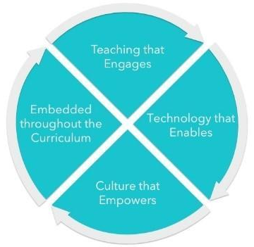
Engage students in digitally rich meaningful, challenging and safe learning environments.
Embed the ICT curriculum into all areas of teaching and learning.

Empower the school community to create, communicate, solve problems, work collaboratively and celebrate using digital technologies.

Enable the school community to be active participants in the 21st century.

Digital technologies are dramatically changing how we educate our students. Increased access to electronic devices such as laptop, computers or tablets and the explosion of online information enables our students to interact with and create high quality content, resources and tools. Through increased access to devices, students can access learning that is interactive, differentiated and collaborative.

For success in this rapidly changing information age, students still require fundamental skills in literacy and numeracy. However, for students to be best prepared for life in the 21st century, evidence that supports the importance of new core skills is recognised. There is a myriad of research on this topic and new educational models emerging. One of these is the 6 C’s of education:
- Creativity
- Collaboration
- Communication
- Critical thinking
- Connectivity
- Culture and character
Bulleen Heights School plays an important role in introducing technology to children and ensuring it is used appropriately to enable efficient and effective teaching and learning practices that prepares students for life and work.
Curriculum Links

Victorian Curriculum F-10: encompasses both ICT and the new Digital Technologies.

ICT is a general capability. The learning of the skills and knowledge defined by the ICT general capability are now embedded in student learning across the curriculum. There is considerable research that identifies the importance of the teaching of ICT in the context of the different curriculum areas.
The Digital Technologies curriculum enables students to become confident and creative developers of digital solutions through the application of information systems and specific ways of thinking about problem solving.
eSmart:
An eSmart school is a school where the smart, safe and responsible use of information and communications technology is a cultural norm. Students, teachers and the wider school community are equipped to embrace the best these technologies can offer, while being savvy about the pitfalls.

Why a 1:1 program?
A 1:1 learning program is a program where each student will have access to a device to support communication and complete learning tasks.

Our Bring Your Own Device (BYOD) program in 2022 is for all identified students including those using the device as communication aid or in addition to.

- 1:1 is about learning rather than technology
- 1:1 is not about having a lesson on iPads – it’s about doing a curriculum-based learning activity that allows the use of an iPad as a tool.
- 1:1 is not going to the computer lab for a technology class, it’s having information and tools at the fingertips of students and teachers whenever the learning task requires it.
- Students see the iPad as their personal learning device. They can set it up to suit their learning needs.

Why iPads?

- Most students have an iPad/iPod/iPhone from home
- Quick to log on
- No loading time of a computer
- No username or password required
- Easy to troubleshoot
- Wider range of user friendly applications and functionality than a laptop/netbook
- Mobile - ideal for investigating and collecting evidence
- Provides easy and regular access to online collaborative spaces - ideal for group work at school
- Does not crowd desks
- iPads are flexible and creative because they cater for all learning styles
- Multi-modal delivery: text, audio, image, video
- Able to adjust text sizes, sounds to suit learner
- Students can express their ideas in different formats
- Once set up, the iPad requires less technical support than similar devices

Supporting research and key findings
There is a rapidly growing body of research which points to the positive effects that 1:1 iPad programs have on educational engagement, motivation, creativity and independence.
The Department of Education and Training (DET) Victoria recently ran an extensive research project ‘iPads for Learning – In Their Hands’ (2010-2011). This placed 700 iPads in nine primary, secondary and special school settings across Victoria.
The trial investigated the capacity of iPads to:
- increase independent and self-initiated learning among students
- increase student motivation and active engagement in learning
- improve teachers’ capacity to plan for and meet individual student needs
- improve student learning outcomes
- extend students’ learning beyond the classroom and
- improve parental engagement in learning and strengthen home-school links.

The iPads for Learning Trial reinforced that quality of teaching, combined with purposeful and effective use of ICT contributes to improved learning.

The iPad has functionality and features that enhance its use as an effective and engaging learning tool.
- The iPad is easy to use. It is intuitive and users of all ages and abilities (including children with learning difficulties) do not require special training or professional learning on how to turn it on, navigate through and use apps, and maintain the iPad (i.e. charge and sync the iPad, update apps).
- The touch-interactive flat screen tablet with pinch in/pinch out functionality provides students with autism, ADHD, visual disabilities and poor fine and gross motor skills with more efficient access to effective learning opportunities.
- High speed access to online information enables more self-directed learning and rapid access to a fast-growing market of relevant and regularly updated educational apps.
- Portability enhances collaboration between students and communication between students and teachers, increases parental engagement in learning and strengthens home-school connections.

The iPad is just a device. It is just another resource, albeit a powerful ‘anywhere, anytime’ tool, in the teaching and learning toolkit.

Quality teaching is the factor which enables the iPad to be used effectively to improve student motivation, engagement and learning outcomes.
- Teachers used the iPad to meet the specific learning needs of students and support engaging, interesting and collaborative learning.
- Students used the iPad to take greater control of their learning, using a single device to search for information on the Internet, practice specific skills with selected apps, create keynotes and multimedia presentations, and present and share their learning with their peers, teachers and family.
- Teachers found the iPad to be an especially valuable learning tool for students with special learning needs due to the combination of its design features, multi-functionality and access to specific purpose apps.
- Students used the iPad to improve their learning outcomes, especially in literacy, numeracy, communication and thinking skills.
- The iPad was used to extend learning beyond the classroom, facilitating learning wherever the student had the iPad (at home, at camp, on an excursion) and increasing parental engagement in learning.

90% of students said that learning was more fun when using the iPads.
- 85% of primary teachers thought that students were more motivated and engaged in learning.
- 90% of students said that learning was more fun when using the iPads.
- 67% of teachers said that use of the iPad had improved their effectiveness as teachers.
- 83% of primary teachers thought that using the iPad had improved students’ literacy.

Teaching and learning success with iPads is more likely where they are used in a supportive school and home environment.
- iPads in the trial had a significantly greater educational impact and were more successfully implemented in primary school settings than in secondary schools.
- Quality teaching is the factor which enables the iPad to be used effectively to improve student motivation, engagement and learning outcomes.
- School leaders actively encouraged the purposeful use of iPads as a strategic support for improving student outcomes, and facilitated teacher access to pedagogically-focused professional learning opportunities.
- Students and teachers had timely access to quality technical advice and support. Once set up, the iPad requires less technical support than similar devices, but a 1-to-1 ICT roll out can put stress on a school’s ICT infrastructure (e.g. network, bandwidth).
- Parents were informed about and understood the way in which the iPads were to be used to support their child’s learning; they participated as necessary in maintaining the device as ‘ready for learning’, and took an active interest in their child’s learning.

iPads in the trial had a significantly greater educational impact and were more successfully implemented in primary and special school settings than in secondary schools.
- This was in part related to structural differences between contemporary primary and secondary classes. That is, a primary teacher has a dedicated class of students and can more easily incorporate cross-curricular learning and inquiry based learning into everyday practice, with the iPad ever-present as a learning tool.
- Primary and special school teachers in the trial also demonstrated greater preparedness and capacity to incorporate the effective use of iPads into learning and assessment activities. They taught lessons where students could choose to use the iPad to facilitate, enhance and share their learning.

How you can expect to see 1:1 been used in the classroom
The success of any BYOD program has always been built around a knowledge of students’ needs, adapting technology to meet these needs and the knowledge of staff members to implement programs and lessons that successfully integrates technologies into all areas of the curriculum which enables students to engage in relevant, interesting and collaborative learning opportunities.
At Bulleen Heights School we expect to see iPads integrated in a meaningful way across the curriculum. Here are some examples of how apps may be used in the classroom.

Application | Overview of app | Links to the curriculum
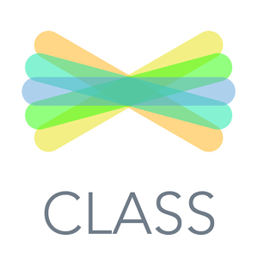 | Seesaw is a digital learning portfolio, used to showcase students’ achievements, creativity and learning within the classroom. This is done by using photos, drawing tools, videos, files, websites and items that students have created using other apps. | - Setting learning tasks  - Metacognitive skills development reflection  - Reflection tasks using pictures and videos  - Explain thinking by recording drawings and/or using video function to record students in action  - Share learning with families and provide real time feedback for students  - Allows for individualized assessment of and for learning (formative and summative)
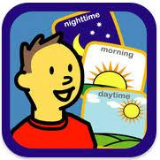 | Choiceworks is a tool to aid students in completing daily routines, regulating emotions and improving waiting skills by using social stories and timers. | - Integrate interactive schedules into morning/ circle time routines  - Use for individual schedules integrating video modeling and student specific rewards  - Social stories and video modeling can be used to aid students identifying and regulating their emotions  - The ‘waiting’ function and schedules can be used to help students transition between activities  - Using the schedule function with pictures of students during turn taking activities
 | Proloquo2Go is a symbol supported communication app designed to help with language development and communication skills. | - Integrating into morning circle and question time talking about what happened on the weekend or previous day  - Have students request highly desired items at meal time  - Describing activities  - Peer communication lessons  - Integrated into literacy lessons having students answer comprehension question or retell stories using pre prepared boards  - During community access or classroom role plays activity to order food or talk to servers  - The app can be integrated into numeracy lessons to describe using it to describe shapes, request a certain amount of counter to solve an equation
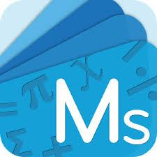 | Mathletics is an app that uses scaffolded interactive games and lessons to help students engage and gain confidence in mathematics while moving through curriculum aligned activities, assessing students and tracking progress. | - Teacher-led instruction, independent and student driven numeracy lessons  - Teachers can create personal and blended learning opportunities for individual students  - Use data to drive teaching and learning for individual students  - Games and workbooks to generalize skills  - Mathletics Live fosters collaboration and engagement as students race with each other while working on the speed and accuracy of their math skills  - Explore open-ended learning tasks with multiple possible outcomes using problem solving and reasoning skills
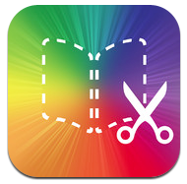 | Book Creator is an application that allows students to combine text, images, audio and videos in order to create different types of text and publish them to the Book Creator community. | - Used to engage students with writing using voice recordings  - Creating social stories that can be shared between home and school  - Create an instructional piece of writing by using pictures, videos and writing to create a recipe book  - Foster communication between students or classrooms by using the app to create a book collaboratively on a topic or idea  - Insert videos and text in order to document changes in matter during science experiments  - Students can use Book Creator to put together a math textbook explaining a concept to another student or share it with parents using Seesaw
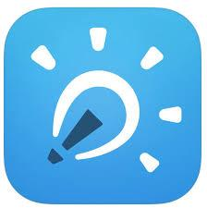 | Explain Everything is an interactive whiteboard that allows students to create videos, tutorials, animated stories and presentations. | - Can be used by teachers using visuals, videos and audio to explain concepts to students  - Use to capture the process of students learning  - Have students work collaboratively with one posing a question and another using tools and features to answer the question
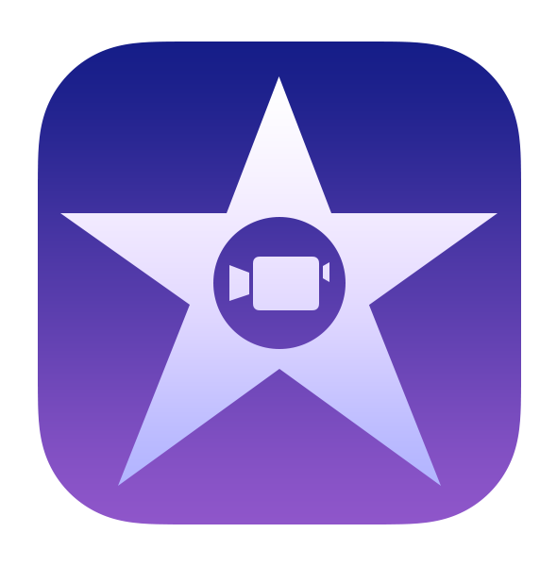 | iMovie allows students to film, edit, add text and audio clips in order to make movies or trailers exploring an activity or concept. | - Using iMovie in classroom projects is a great way to promote a culture of collaboration and cooperation among students  - Use titles and voice overs during science to label different types of clouds or identify the different plants and animals in a short clip  - Track students reading progress over multiple clips  - Engage students by creating a movie version of their favourite book using voiceovers, titles and sound effects  - Encourage cross curriculum skills while developing storyboards, scripts, filming and editing movies on a range of subjects
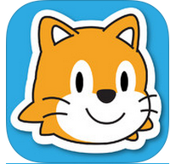 | Scratch Jr. is an app and website that allows students to learn the fundamentals of block coding while they program their own interactive stories and games. | - Develop problem solving skills while programing different characters  - Encourage collaboration when students share the game that they have coded with their classmates  - Reinforce student literacy and numeracy skills by having students animate different letters and numbers
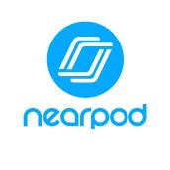 | Nearpod is an interactive presentation and assessment tool. | - Use Nearpod to deliver a teacher lead interactive presentation easily to each student's iPad  - Personalize learning to meet the needs of each individual student by getting them to work through presentations aimed at their specific level  - Using the homework feature to promote independence by having students work through presentations at their own pace  - Promote collaboration and discussion using the collaborate feature  - Can be used for formative, ongoing and self -assessment  - Use the quiz feature to assess students understanding of a topic or prior knowledge  - Assessment data can be read live while students are taking part in the test or teachers can generate reports from the nearpod website
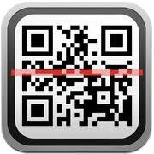 | Short for quick response QR codes. Readers allow teachers to present videos, reading material, cues and questions, websites, images and questions to students in code form. | - Use for video modelling linking videos to code that can be place around the students environment and scanned when needed  - Promote independence by putting answer to question on QR code and have student self-correct work  - Use QR code scavenger hunts to get students up and moving around the classroom  - Convert questions or numeracy problem into QR code that student can independently work on  - Instead of printing worksheets, use codes to directly provide information to the students individual iPad  - Display work, create live bulletin boards that can update quickly  - Use QR book codes to give students easy access to clips of their books being read or have students create their own
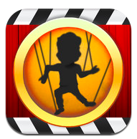 | Puppet Pals can be used to create animated cartoons using a variety of themes and characters. | - Use puppet pals during your speaking and listening lessons to engage students in conversations by using puppets to answer and pose questions  - Import students pictures and have them animate expected behaviours or reenact a situation  - Import background and character and use to demonstrate situations that students will encounter while out in the community  - During numeracy lessons bring problem solving equations to life while students use puppets to work through a problem  - Use puppet to tell stories or talk about a historical event
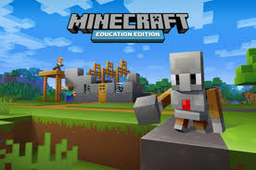 | Minecraft Education Edition | - DET backed and evidenced based educational tool to be used in school  - Can be used as a classroom tool to approach literacy and numeracy goals  - Promote whole class collaboration to achieve common goals and support PBS values by respecting each others environment  - Provided free of charge by the State government
 | Sora | - access to eBooks  - use the schools libary subscriptions  - link to local libraries to access their eBook and audiobook library

