Dear parents and carers,

RE: Bring Your Own Device (BYOD) program and requirements

At Bulleen Heights School we are committed to providing our students with access to quality resources including appropriate technologies and digital learning tools. These resources allow our students to better engage with their learning, be enabled to participate, communicate and develop 21st century skills.
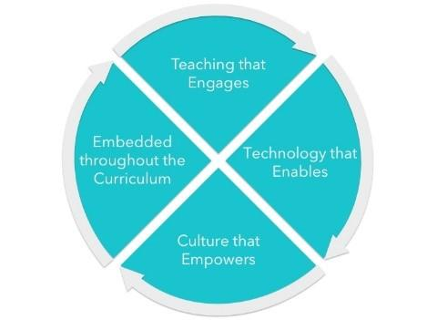

A 1:1 learning program is a program where each student has access to a device to support communication and complete learning tasks. We will be extending our BYOD program in 2021 to all new students on the Manningham Road Campus.

The device requirements for this program are; iPad 8th Generation with a minimum of 128GB storage. We also recommend the Otterbox Defender case to protect your investment. Devices could be purchased from the JB Hi-Fi Education link on our school’s website. Use the school code BHS2021 when logging on to enjoy discounted prices. Please note that after online purchases have been made, an email confirmation will be sent to you once the device is ready for collection. Devices are usually available 2-3 days once orders are received. JB Hi-Fi education prices are not available for purchases made in store or at the JB Hi-Fi online store.

To help us to better plan for the implementation of this program, please indicate your preference on the following page and return it to the school. Further information about this program, its intentions and how we propose to enhance your child's learning will be provided during the parent teacher meetings. Please feel free to contact the Assistant Principal (Rohan Gosden) or ICT Leading Teacher (Eva Chakrabarty) with any queries or concerns.

Kind Regards,
ICT Leadership Team

Bring Your Own Device (BYOD) Survey of Parent Commitment

Please tick all the statements that apply to you and return it to school.

- I plan to purchase a new iPad that meets the school’s specifications for my child for use in the BYOD program.
- I will purchase this privately.
- I would like to be contacted about the JB Hi–Fi or Apple Family purchasing program.
- My child already has an appropriate device for use in the BYOD program.
  - I have the Proloquo2Go app installed.
  - I have other communication apps on the iPad (please list the apps below)
________________________________________________________________
  - My child does not require an iPad for communication.
- Purchasing a new device is not an option for me.
  - Please contact me about how my child can participate in a BYOD class.

Comments:

____________________________________________________________________________________________________________________________________________________________________________________________________________________________________________________________________________________

My name: _____________________________________________________________________

My child’s name: _____________________________________________________________________

My contact details: _____________________________________________________________________

